MIDDLE ATLANTIC REGION
FEDERATION OF JEWISH MEN’S CLUBS

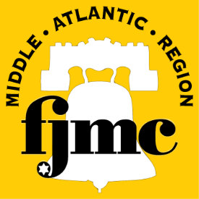

17TH ANNUAL MAN OF THE YEAR DINNER

Sunday, December 7, 2014
Cocktail Hour begins at 4:30PM

Congregation Beth El
8000 Main Street
Voorhees, NJ

Please join us for a Gala Dinner
and Awards Ceremony
to honor Club’s Name‘s

Man of the Year

Honoree Name

Couvert: $ 70.00/person

For further information, please contact: Club’s MOTY dinner coordinator

